Running COBOL in VS Code with GnuCOBOL — Trainer Guide
Nov 6, 2026 · @Johnico Irinco
This guide walks a trainee through compiling and running three sample COBOL programs in VS Code with GnuCOBOL — from a one-screen HELLO to a payroll run that uses copybooks, a called subprogram and file I/O. Every step shows what to click or type, with the spot highlighted on a screenshot.

What you will build
Three labs, each a step up. All of them compiled and ran cleanly with GnuCOBOL 3.1.2 before this guide was written.
Lab | Program | What it shows | Copybooks used
1 | HELLO.cbl | Compile, run, DISPLAY, ACCEPT FROM DATE/TIME | none
2 | LOANCALC.cbl | ADD / SUBTRACT / MULTIPLY / DIVIDE REMAINDER, COMPUTE ROUNDED, **, PERFORM VARYING, edited PICs | none
3 | EMPPAY.cbl + CALCTAX.cbl | COPY in an FD, COPY REPLACING, LINE SEQUENTIAL in/out, FILE STATUS, static CALL with a shared parm copybook, RETURN-CODE | EMPREC, TAXPARM, RPTLINES
The files are in C:\Mainframe Skill for Training\example, laid out like a small PDS set:
Folder | Mainframe equivalent | Contents
src | SOURCE PDS | HELLO.cbl, LOANCALC.cbl, EMPPAY.cbl, CALCTAX.cbl
copybooks | COPYLIB (SYSLIB) | EMPREC.cpy, TAXPARM.cpy, RPTLINES.cpy
data | Datasets | EMPLOYEE.DAT (80-byte input, 7 test records); PAYROLL.RPT is written here
bin | LOADLIB | compiled .exe files land here
.vscode | Site standards | tasks.json (one-key compile/run), settings.json (column rulers, copybook path), extensions.json
The employee data is invented test data — no real people or customer records.

Before you start
You need three things on the PC: VS Code, GnuCOBOL (cobc) on the PATH, and the COBOL extension.
- VS Code — any current version.
- GnuCOBOL 3.x for Windows — a build that includes its C compiler (for example the MSYS2 package mingw-w64-ucrt-x86_64-gnucobol, or a prebuilt GnuCOBOL Windows bundle). Add its bin folder to PATH, then close and reopen VS Code so the terminal sees it. You will confirm it in Step 2.
- COBOL extension by Bitlang — gives colouring, column guides and Ctrl+Click into copybooks:
  - Click the Extensions icon on the left bar (or press Ctrl+Shift+X).
  - Type COBOL bitlang in the search box.
  - Click COBOL (publisher bitlang) and press Install. Once installed it shows a gear icon instead of the Install button, as in Figure 1.
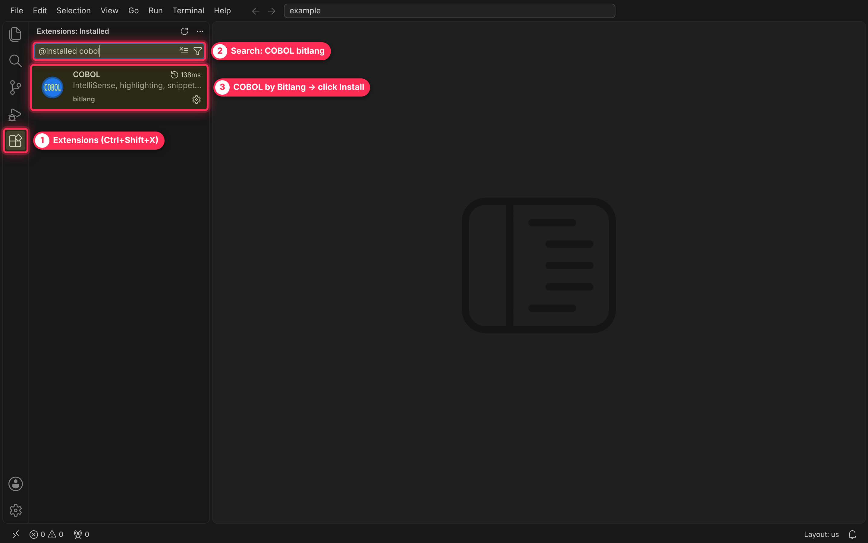
Figure 1 — Extensions view: the installed COBOL extension by Bitlang.
The project already has .vscode/extensions.json, so VS Code may also pop up “Do you want to install the recommended extensions?” — clicking Install there does the same thing.
About the screenshots: they were captured in VS Code with a PowerShell terminal. On your Windows PC the menus and panels look the same; the only difference is the prompt, which reads PS C:\Mainframe Skill for Training\example> instead of PS /Mainframe Skill for Training/example>. Every command in this guide uses forward slashes, which PowerShell on Windows accepts as-is.

Step 1 — Open the project folder
Always open the folder, not single files: the compile commands use paths relative to it, and .vscode/tasks.json only loads this way.
- Click File on the menu bar.
- Click Open Folder… (shortcut Ctrl+K Ctrl+O).
- Browse to C:\Mainframe Skill for Training\example and click Select Folder. If VS Code asks “Do you trust the authors?”, click Yes, I trust the authors.
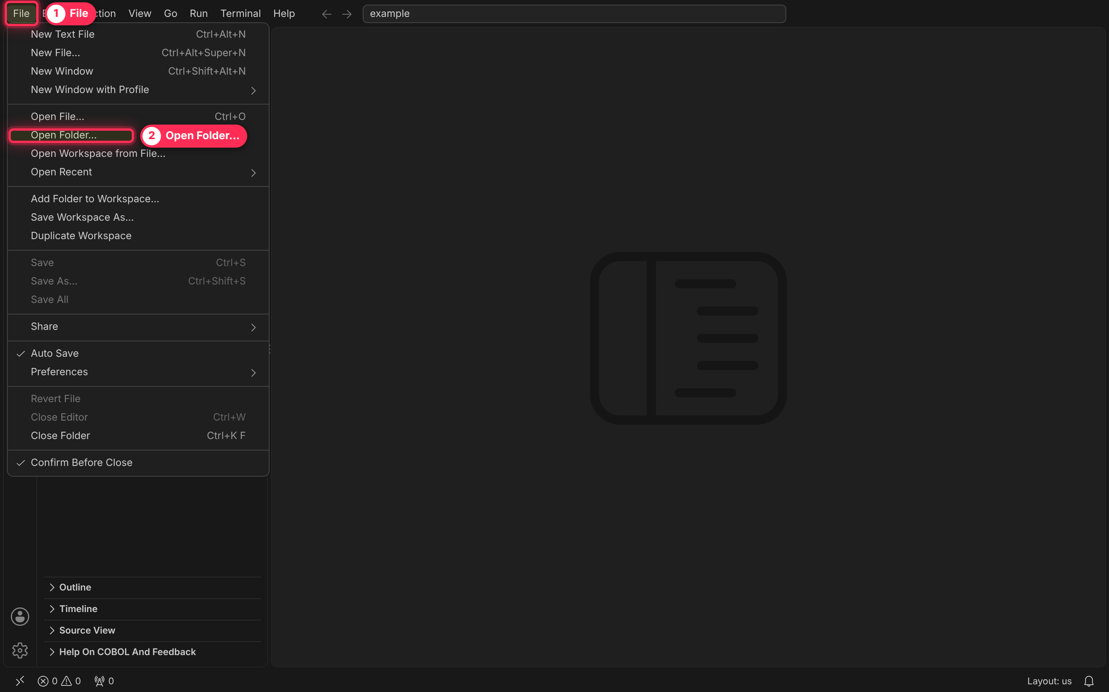
Figure 2 — File › Open Folder…
The Explorer (the top icon on the left bar, Ctrl+Shift+E) now shows the project. Click each folder arrow to expand it.
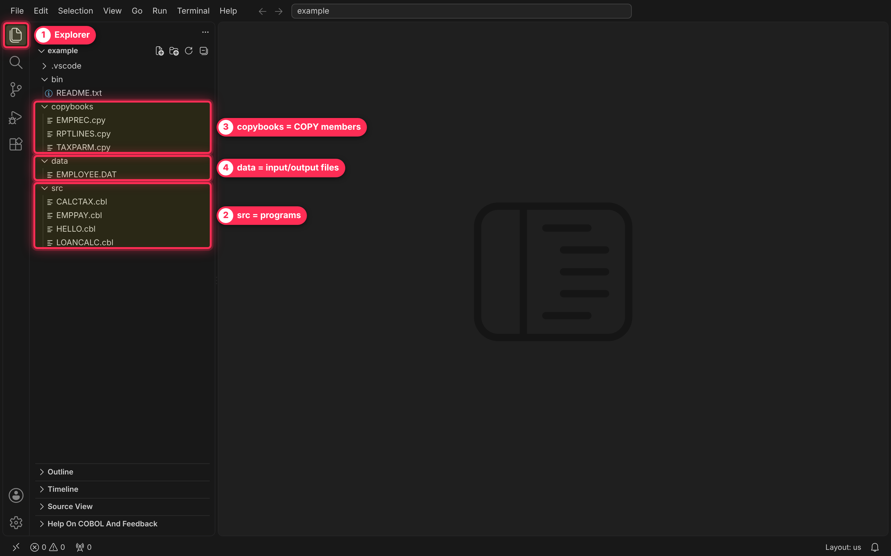
Figure 3 — The project in the Explorer: programs, copybooks and data.

Step 2 — Open a program and a terminal
- In the Explorer, expand src and click HELLO.cbl. It opens in the editor with COBOL colouring and vertical guides at columns 7, 8, 12 and 72 (indicator, Area A, Area B, end of the code area). The status bar at the bottom right should say COBOL.
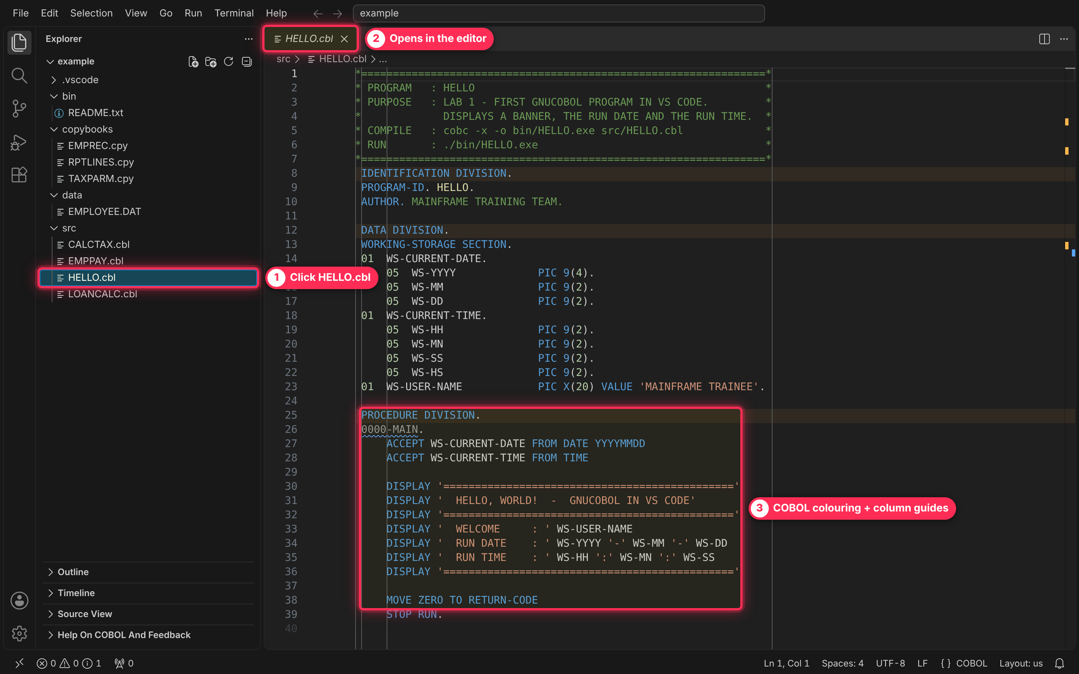
Figure 4 — HELLO.cbl open in the editor.
- Click Terminal on the menu bar, then New Terminal (shortcut Ctrl+`). A terminal panel opens at the bottom, already sitting in the project folder.
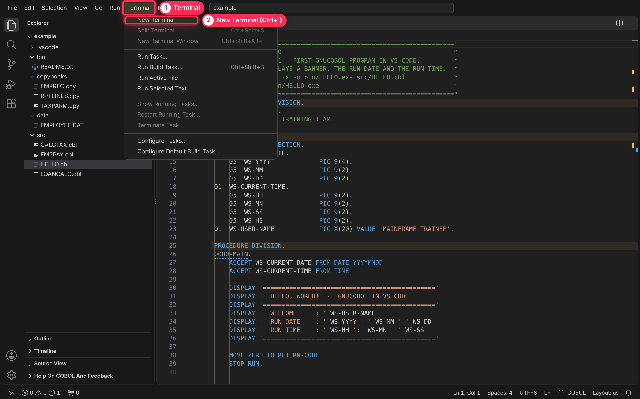
Figure 5 — Terminal › New Terminal.
- Click inside the terminal, type the line below and press Enter:
cobc --version
You should see cobc (GnuCOBOL) 3.x. If you get “cobc is not recognized”, see Troubleshooting.
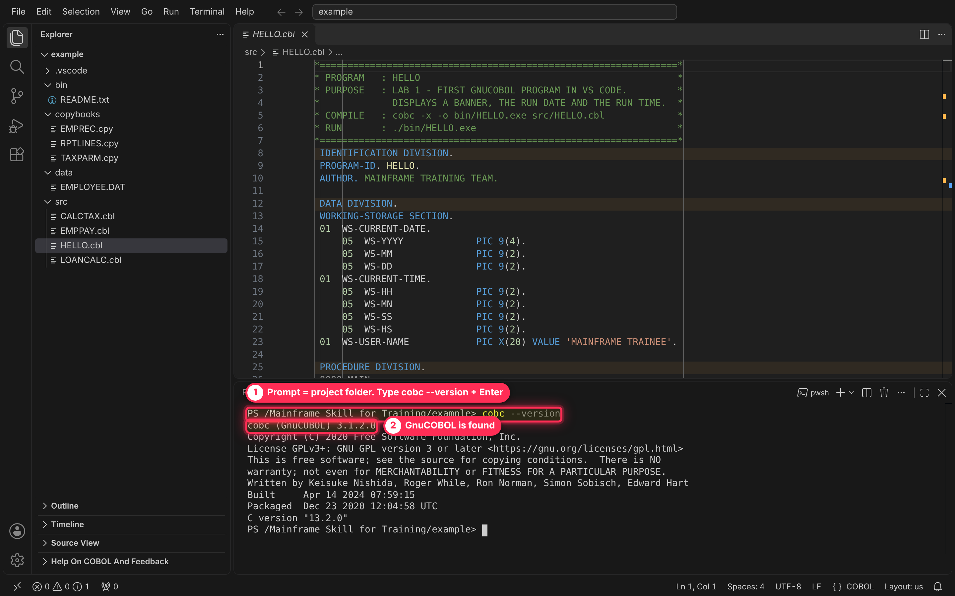
Figure 6 — cobc --version confirms GnuCOBOL is on the PATH.

Lab 1 — HELLO: compile and run
Compile (the IGYCRCTL + link step in one command). Type in the terminal and press Enter:
cobc -x -o bin/HELLO.exe src/HELLO.cbl
Part | Meaning | Mainframe equivalent
-x | Build a runnable main program | Link-edit with an entry point
-o bin/HELLO.exe | Where the executable goes | SYSLMOD member in the LOADLIB
src/HELLO.cbl | The source to compile | SYSIN
A clean compile prints nothing — the prompt just comes back, and HELLO.exe appears under bin in the Explorer (click the refresh icon at the top of the Explorer if it does not show).
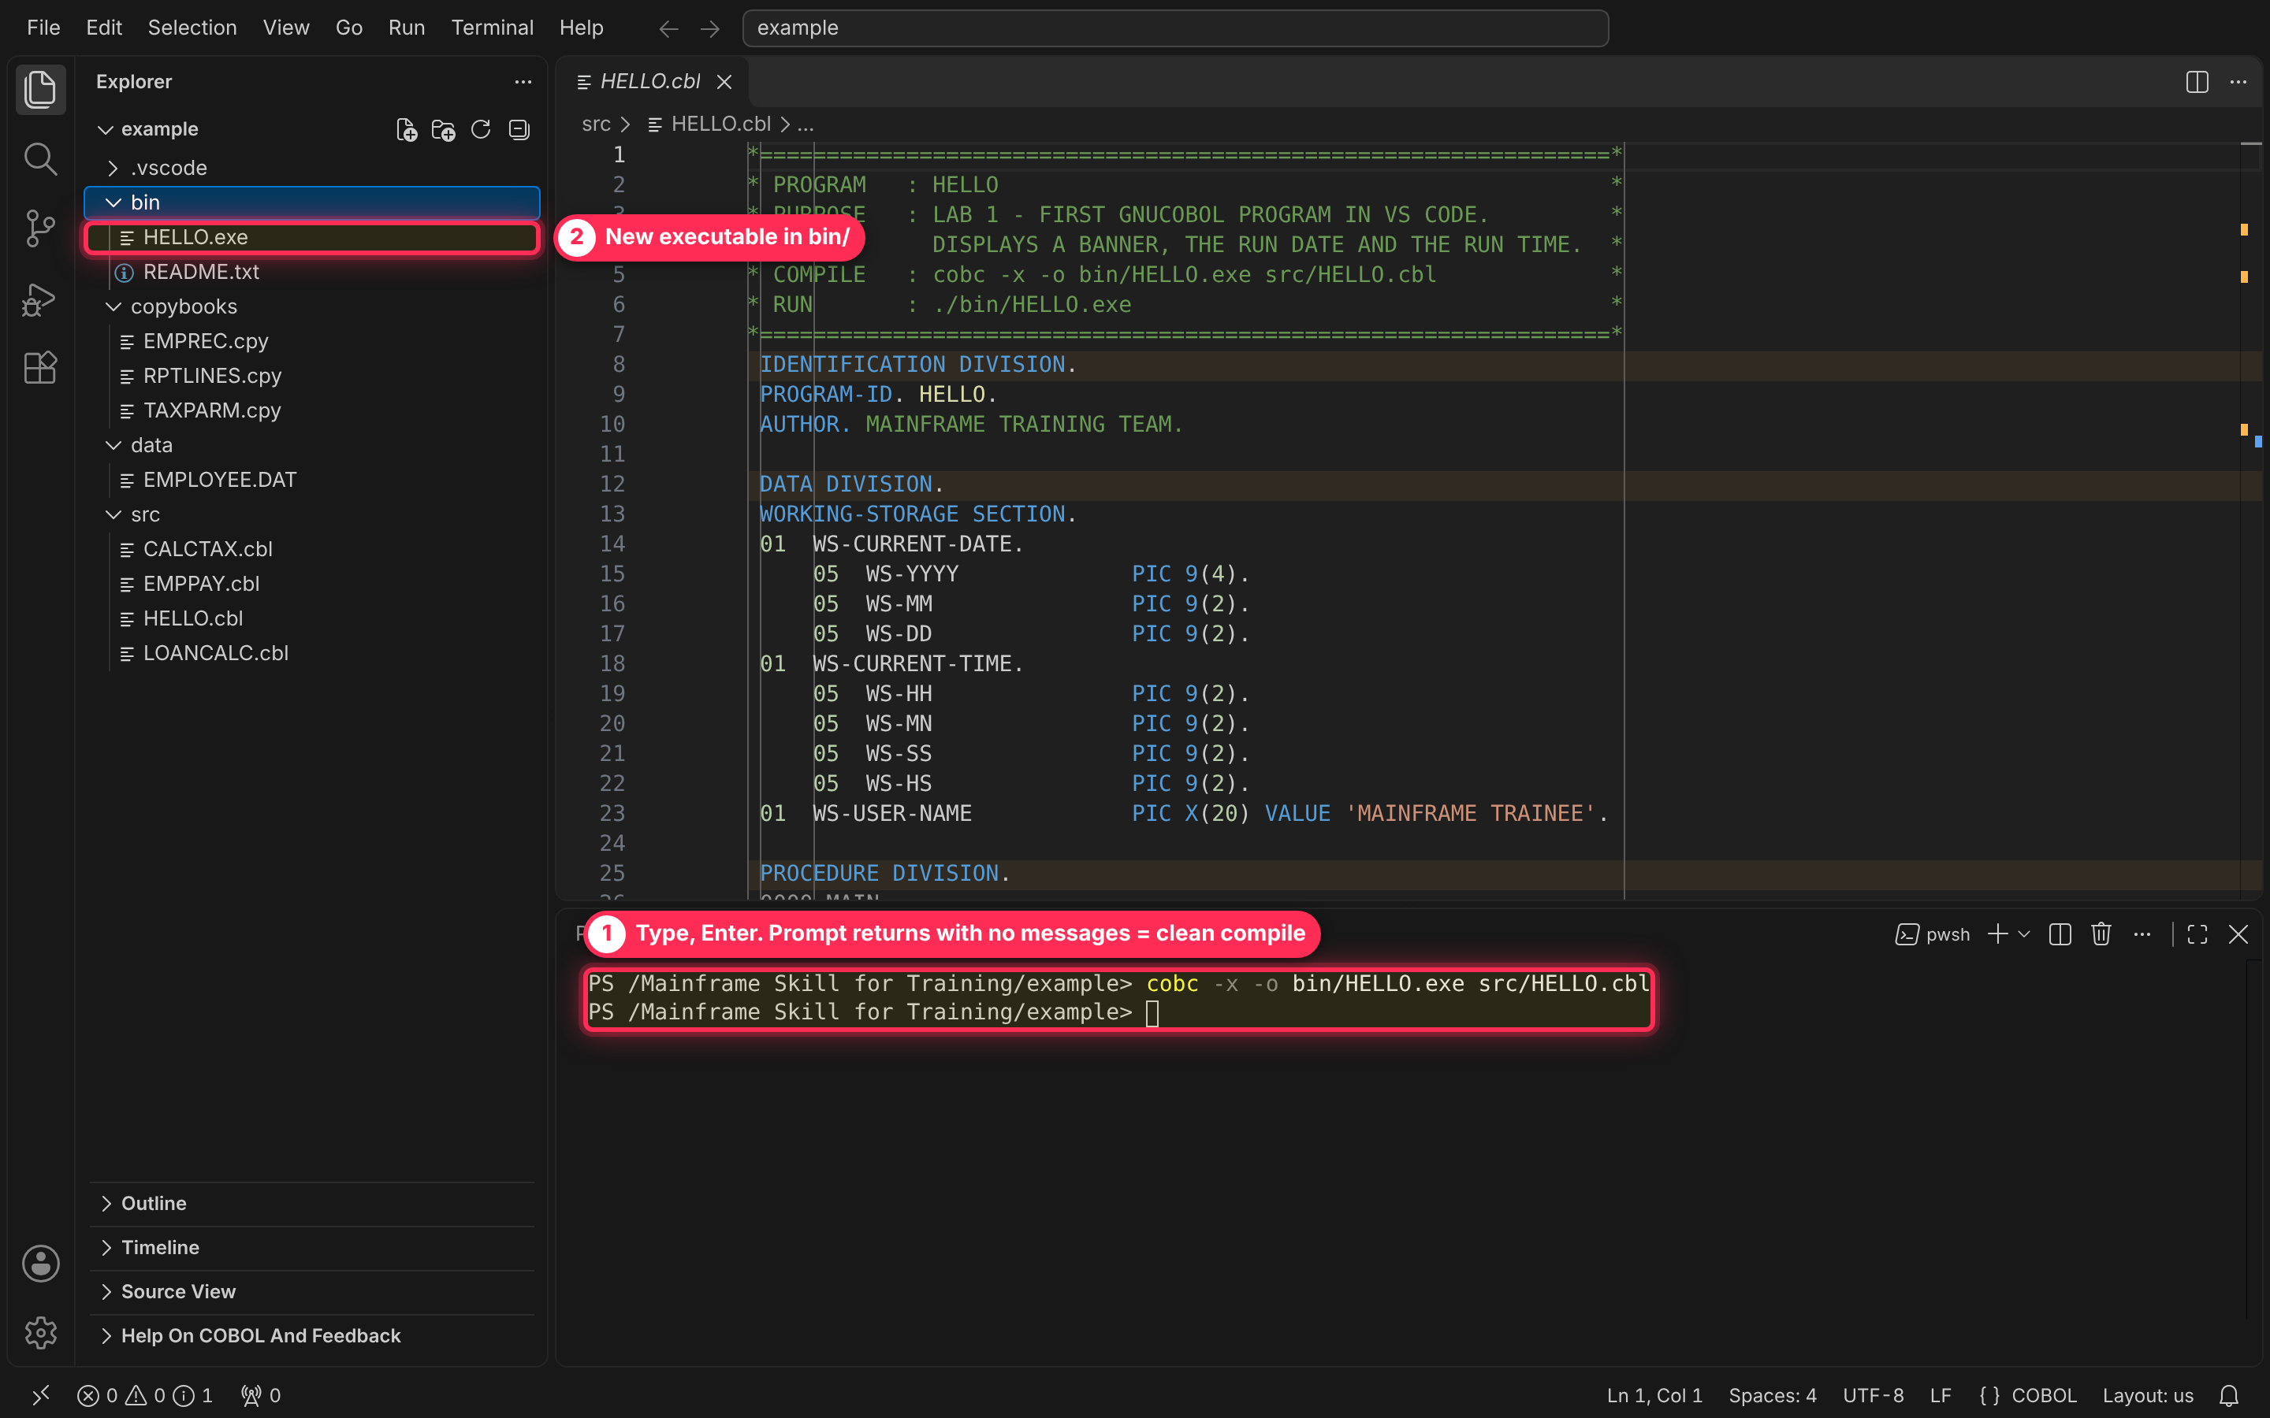
Figure 7 — Clean compile: no messages, and bin/HELLO.exe appears.
Run (the EXEC PGM= step). Type and press Enter:
./bin/HELLO.exe
The DISPLAY output is your SYSOUT: a banner, today's date and the time.
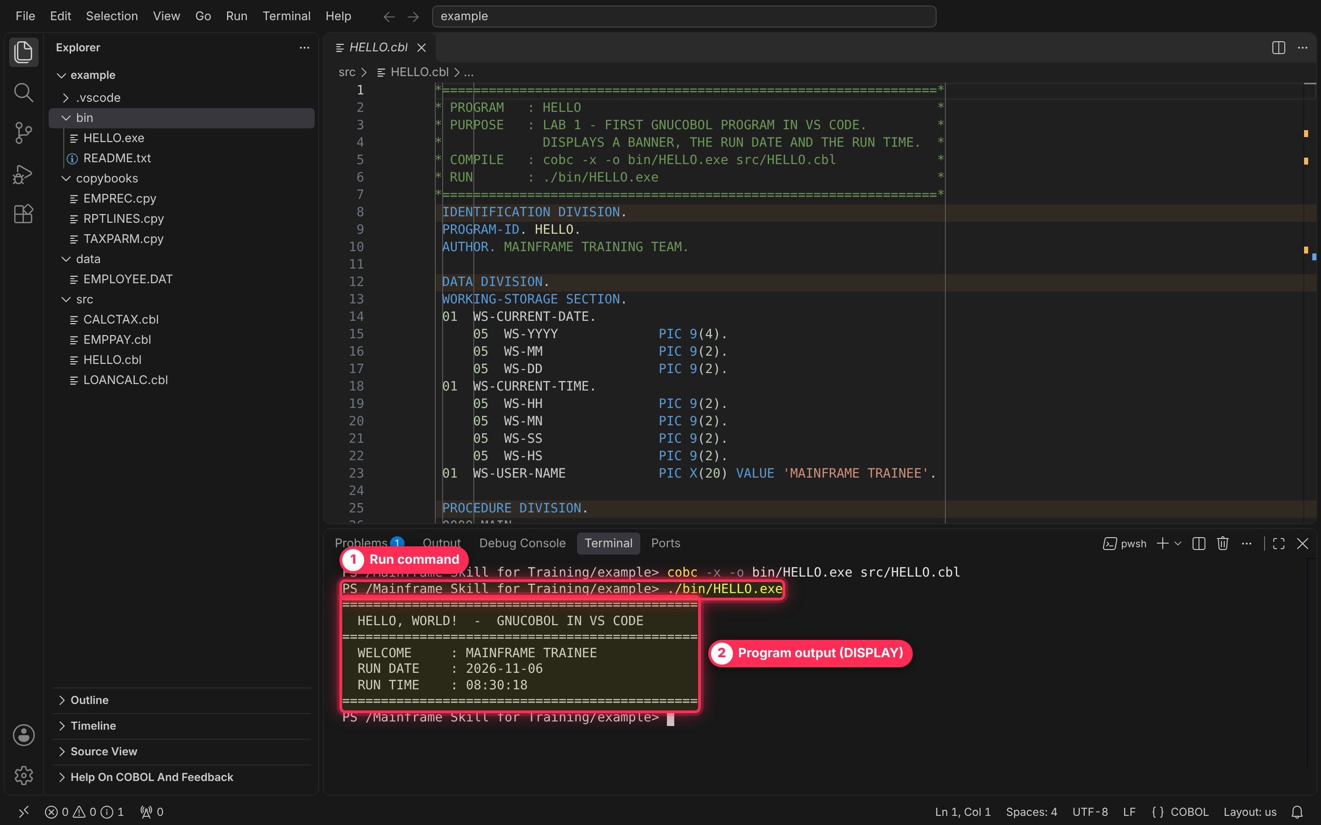
Figure 8 — HELLO output in the terminal.
Try it: change 'MAINFRAME TRAINEE' in WS-USER-NAME to your own name, save with Ctrl+S, then press the Up arrow twice in the terminal to recall the compile command, Enter, and run again.

Lab 2 — LOANCALC: sample computations
LOANCALC needs no input. Part A runs the four arithmetic verbs and a COMPUTE ROUNDED on A = 125.50 and B = 20.00. Part B prices a 25,000.00 loan at 6.5% a year over 12 months and prints the schedule with PERFORM VARYING.
- Click LOANCALC.cbl in the Explorer to look at the code (optional).
- In the terminal, compile, then run:
cobc -x -o bin/LOANCALC.exe src/LOANCALC.cbl
./bin/LOANCALC.exe
To see all the output at once, click the Maximize Panel button at the terminal panel's top right (the square-corners icon next to the X); click it again to restore.
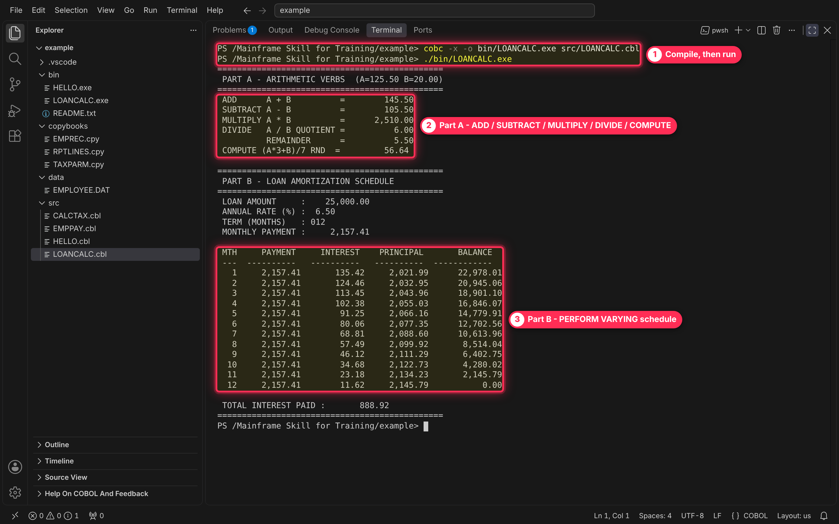
Figure 9 — LOANCALC output: Part A verbs and Part B schedule.
Check the results with the class: monthly payment 2,157.41, total interest 888.92. Month 12 pays off exactly what is left (the program adjusts the last payment for rounding), so the balance lands on 0.00.
Try it: change WS-PRINCIPAL, WS-ANNUAL-RATE-PCT or WS-TERM-MONTHS (keep the PIC sizes), recompile and rerun. A 24-month term doubles the schedule.

Lab 3 — EMPPAY + CALCTAX: copybooks and a CALL
EMPPAY reads data/EMPLOYEE.DAT, works out gross pay (hours over 40 at 1.5× for full-time staff), CALLs CALCTAX for tax and net pay, and writes data/PAYROLL.RPT. It uses three copybooks:
Copybook | Where it is copied | What it holds
EMPREC.cpy | FD EMP-FILE in EMPPAY | The 80-byte input record, with 88-levels for full-/part-time
TAXPARM.cpy | WORKING-STORAGE in EMPPAY and LINKAGE in CALCTAX | The parameter area passed on the CALL; its :P: tag becomes WS or LK through COPY REPLACING
RPTLINES.cpy | WORKING-STORAGE in EMPPAY | Report heading, detail, error and total lines

3a. Look at the COPY statements
- Click EMPPAY.cbl in the Explorer and scroll to lines 30–65.
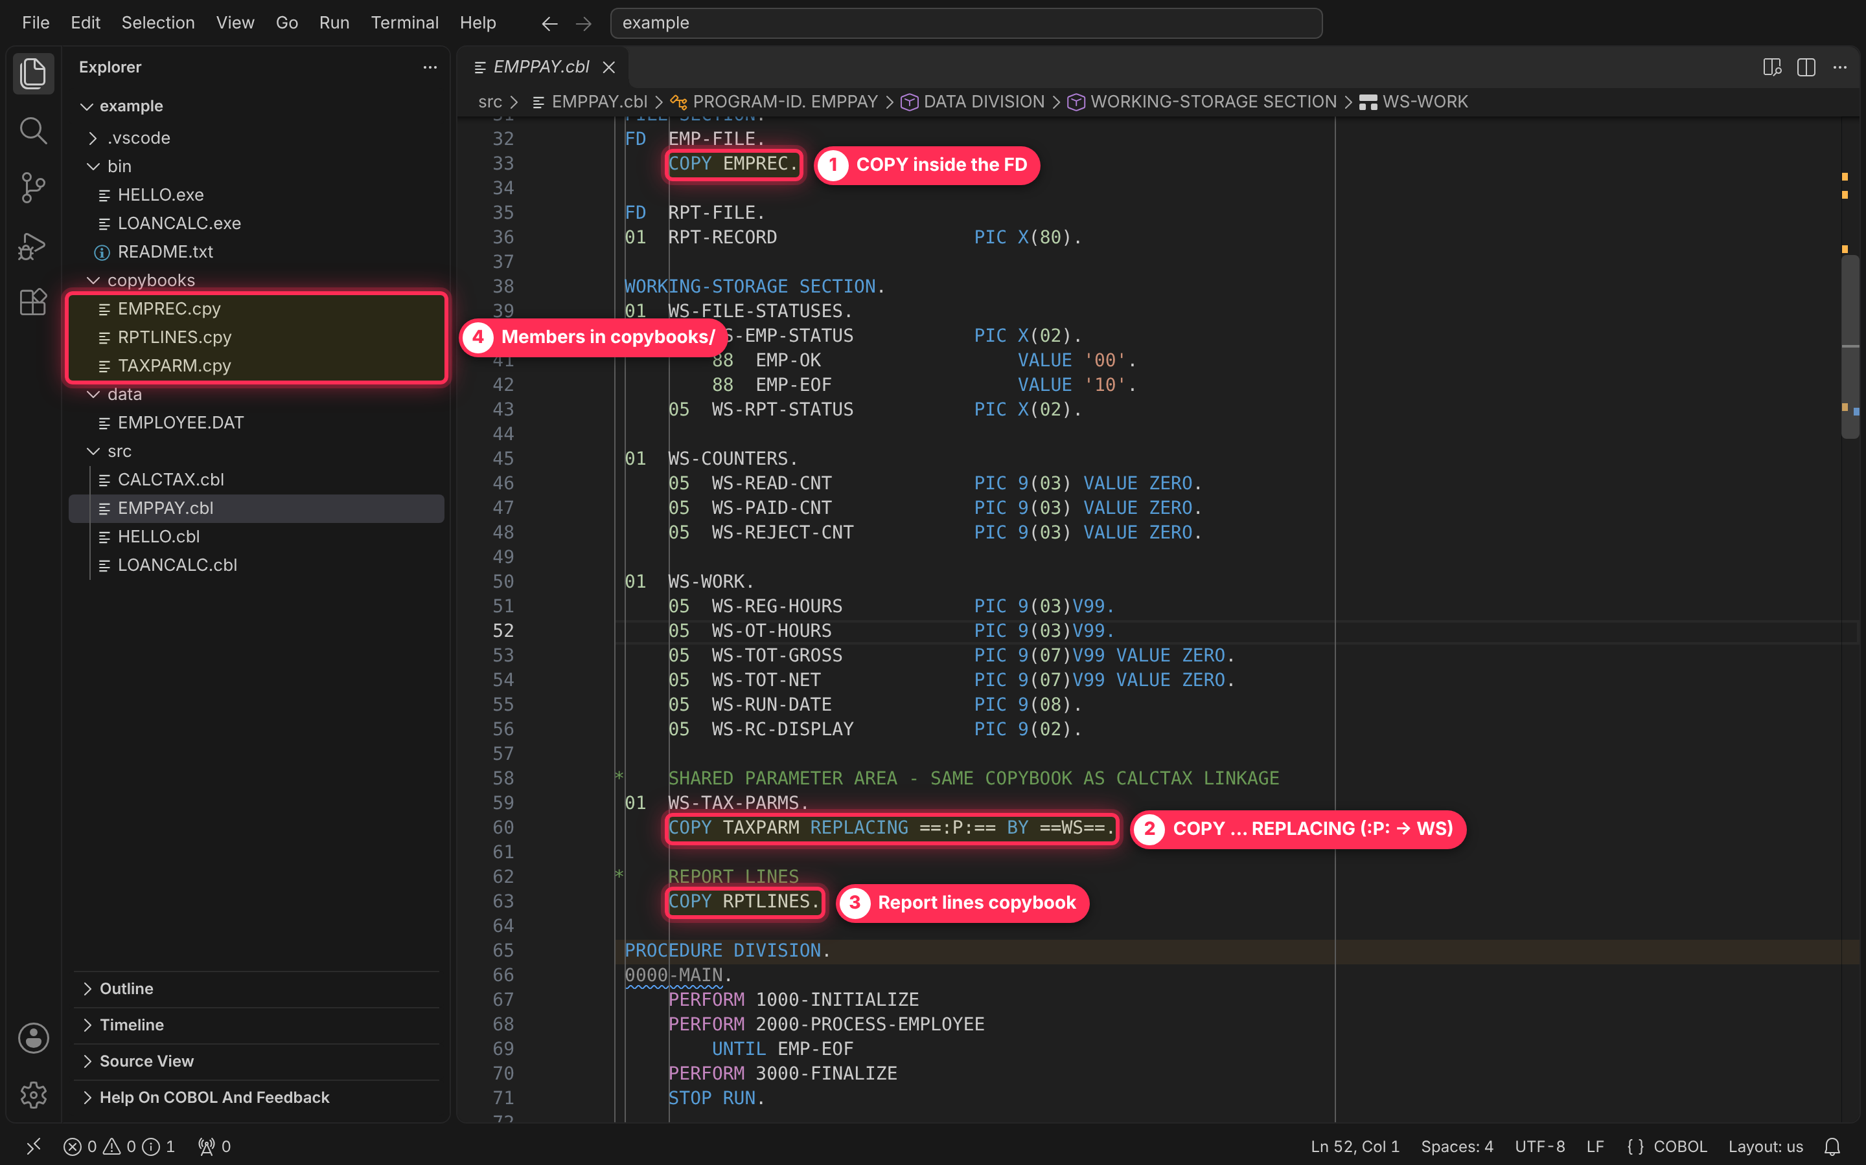
Figure 10 — The three COPY statements in EMPPAY.cbl.
- Click on the word EMPREC in COPY EMPREC. and press F12 (or hold Ctrl and click it). The copybook opens in its own tab. This works because .vscode/settings.json tells the extension to look in the copybooks folder.
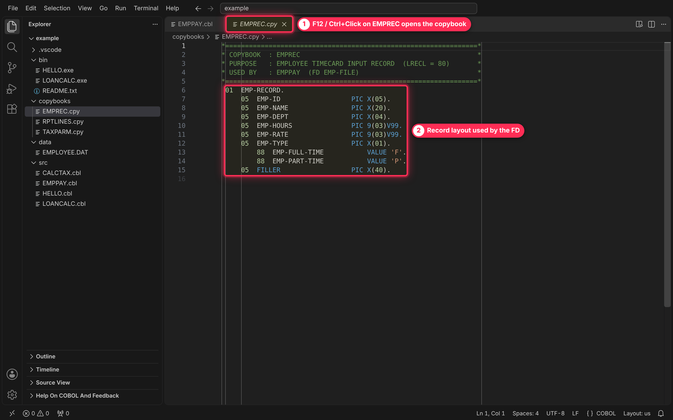
Figure 11 — F12 on EMPREC opens the copybook.

3b. See what happens without the copybook path
This is the most common first-day mistake, so let trainees hit it once. Click back on the EMPPAY.cbl tab and run this in the terminal — note there is no -I copybooks:
cobc -x -fstatic-call -o bin/EMPPAY.exe src/EMPPAY.cbl src/CALCTAX.cbl
cobc stops at each COPY with “No such file or directory”, and every field from those copybooks is then reported as “not defined”. Scroll the terminal to the top to see the first errors — they are the real cause; the rest are knock-on errors.
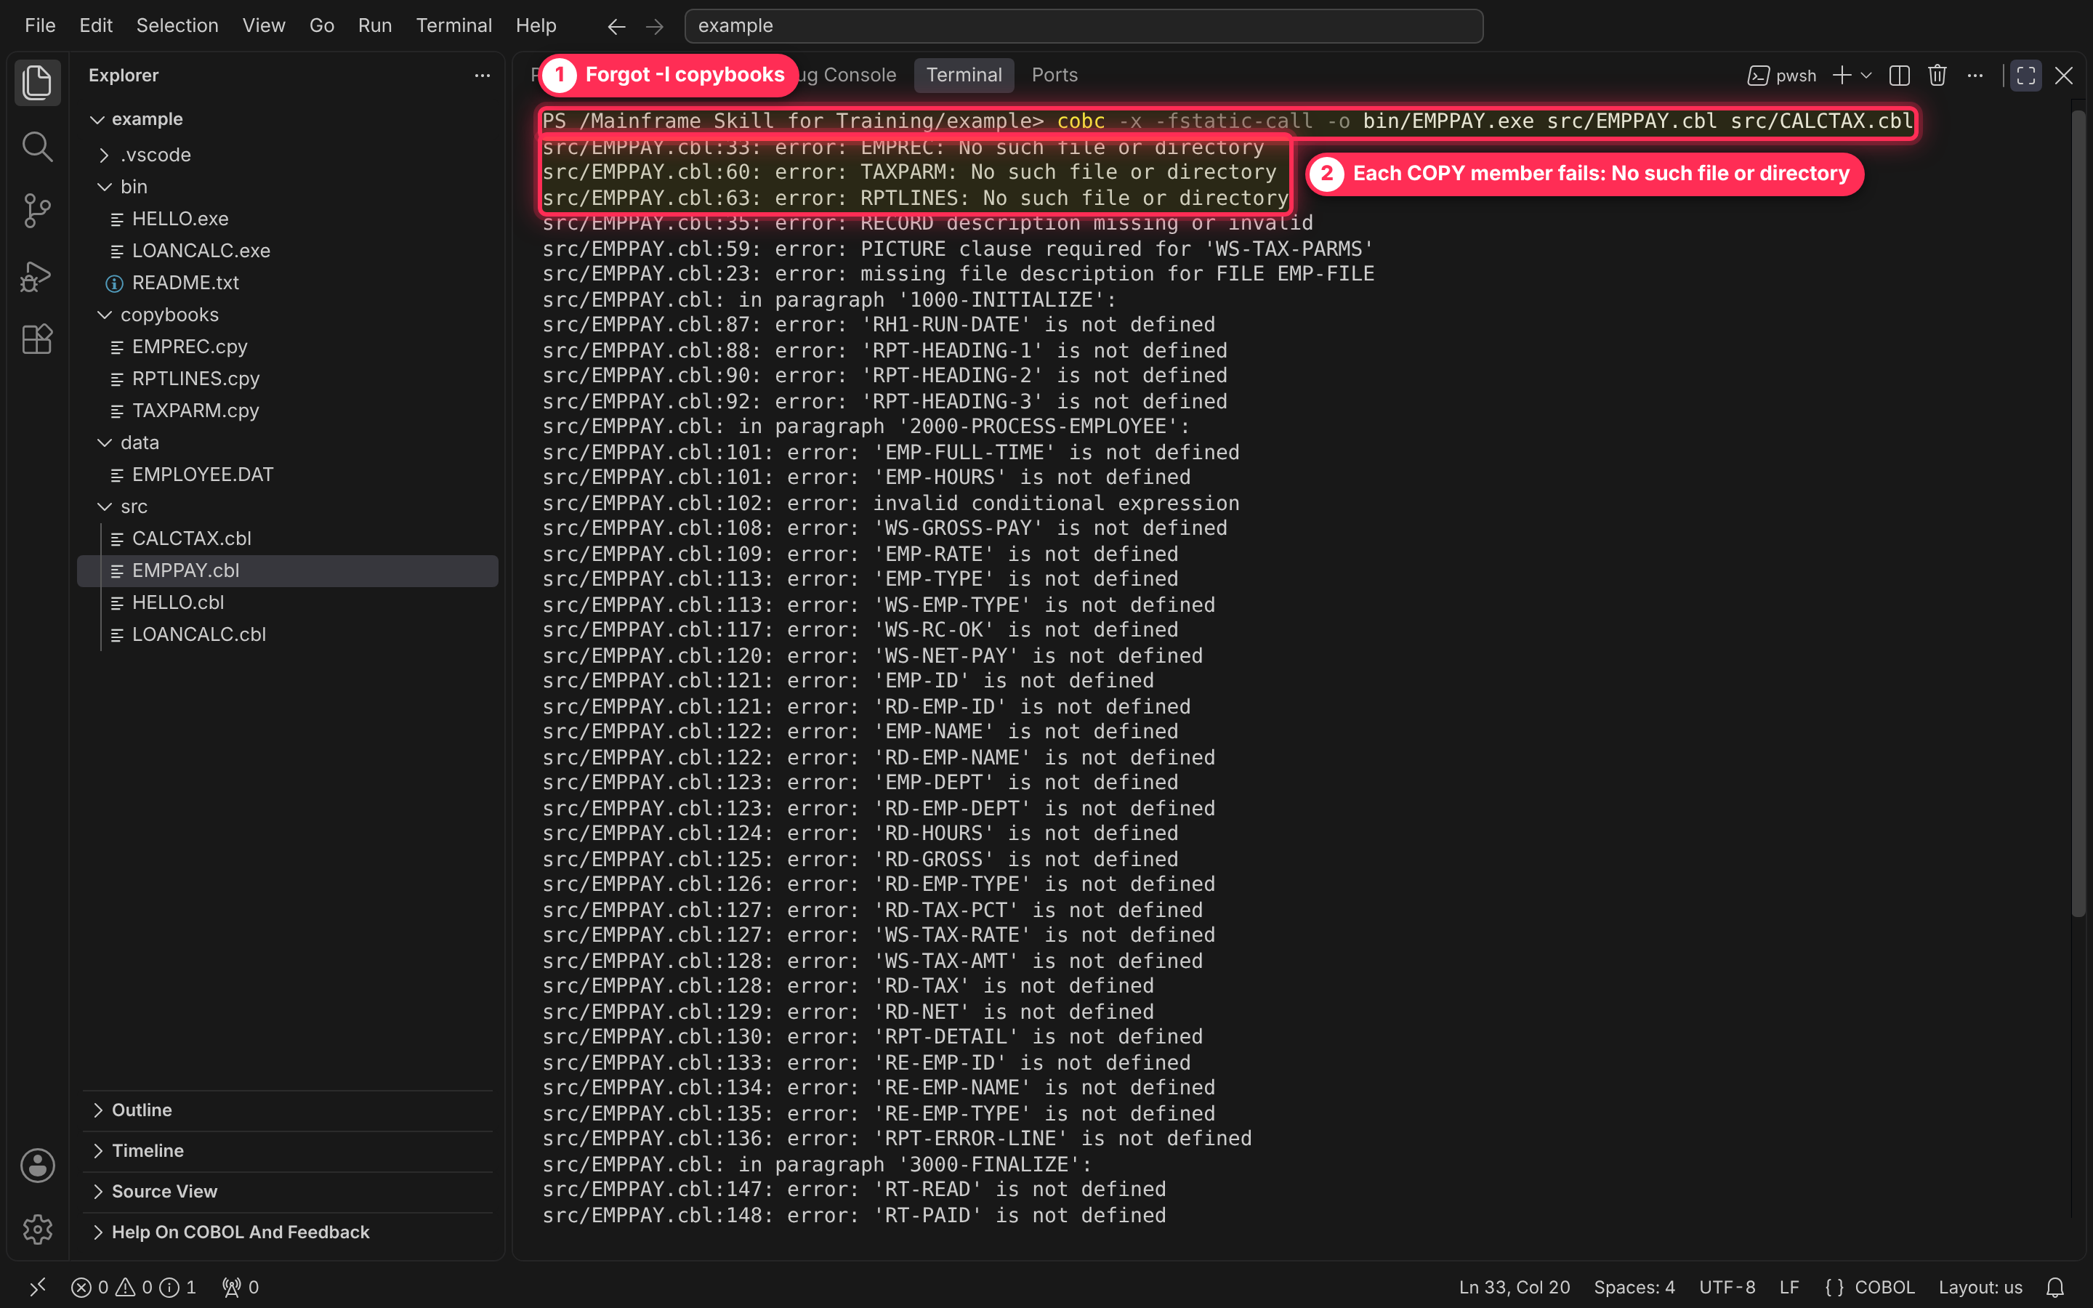
Figure 12 — Missing -I copybooks: each COPY member is not found.

3c. Compile correctly
cobc -x -fstatic-call -I copybooks -o bin/EMPPAY.exe src/EMPPAY.cbl src/CALCTAX.cbl
Part | Meaning | Mainframe equivalent
-I copybooks | Folder to search for COPY members | //SYSLIB DD concatenation
-fstatic-call | Resolve CALL 'CALCTAX' at link time | NODYNAM compiler option
src/EMPPAY.cbl src/CALCTAX.cbl | Compile both and link into one executable | Main + subprogram in one load module
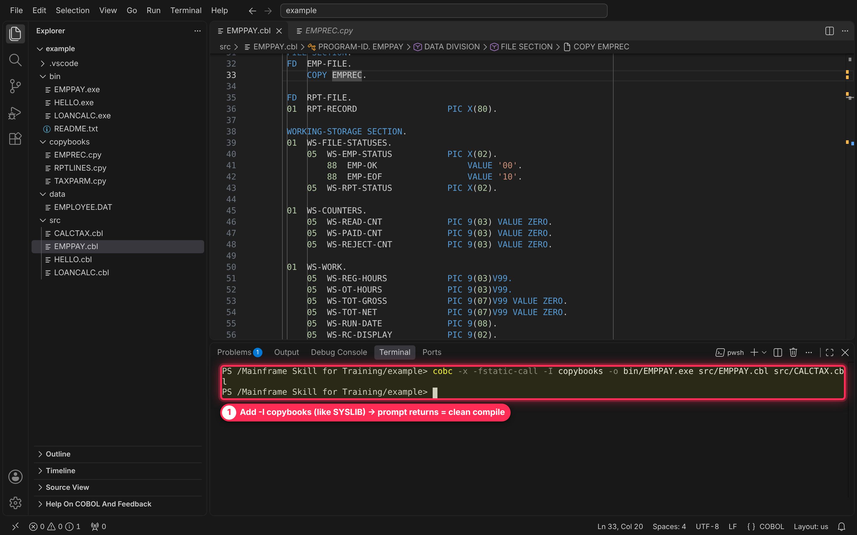
Figure 13 — With -I copybooks the compile is clean.

3d. Run it and check the return code
Run from the project folder (the file paths in the SELECTs are relative to it), then show the step return code:
./bin/EMPPAY.exe
$LASTEXITCODE
Six employees are paid. E1005 has an invalid type X, so CALCTAX returns RC 08 in the parameter area, EMPPAY prints a REJECTED line and ends with RETURN-CODE 4 — the PC version of COND CODE 0004. (In a Command Prompt instead of PowerShell, use echo %ERRORLEVEL%.)
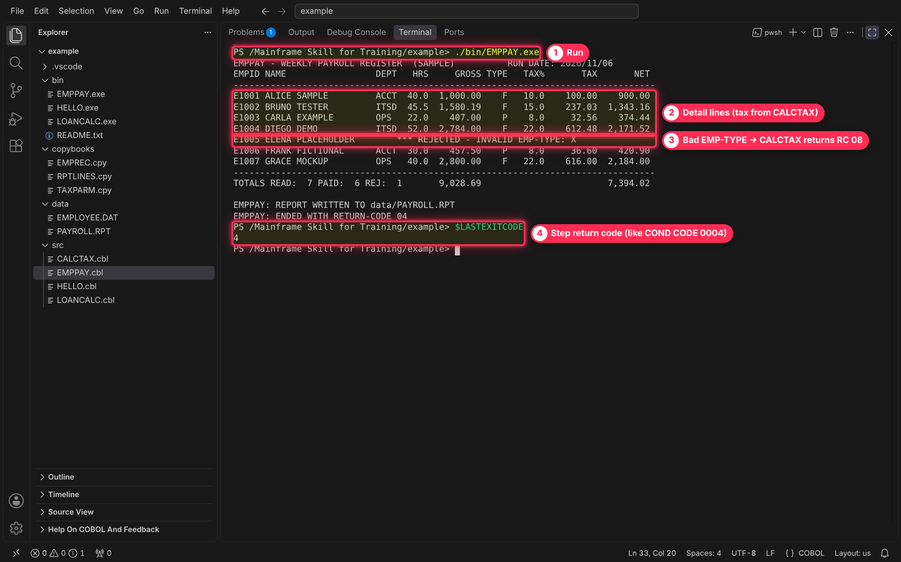
Figure 14 — EMPPAY output and return code 4.

3e. Open the report file
In the Explorer, click the data folder twice to refresh it, then click PAYROLL.RPT. It holds the same lines EMPPAY displayed — the equivalent of browsing the output dataset.
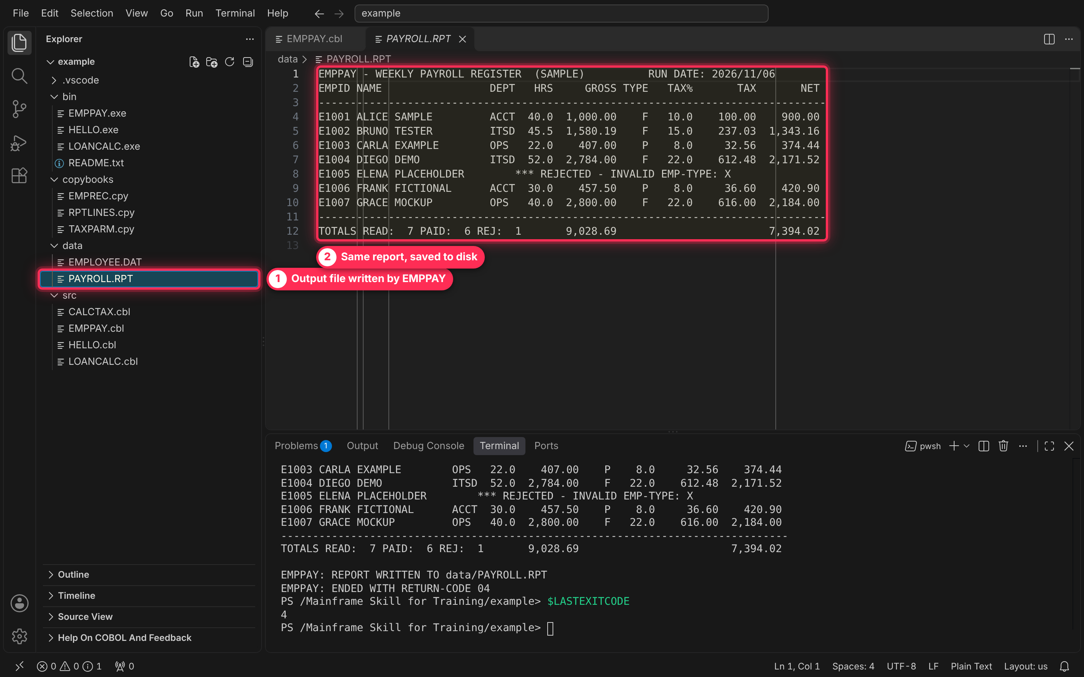
Figure 15 — data/PAYROLL.RPT written by EMPPAY.
Try it: edit data/EMPLOYEE.DAT and change E1005's last character from X to F (column 40 — the status bar shows the column). Rerun EMPPAY: no rejects and $LASTEXITCODE is 0.

Shortcut — compile and run with VS Code tasks
Once trainees know the commands, .vscode/tasks.json saves the typing — think of the tasks as cataloged PROCs.
Pick a task from the menu
- Click Terminal on the menu bar.
- Click Run Task…
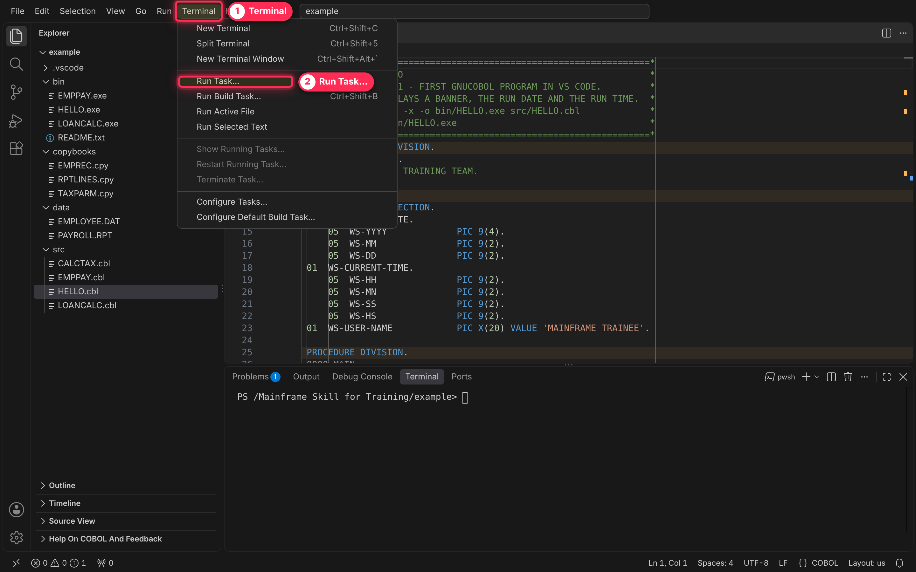
Figure 16 — Terminal › Run Task…
- Choose one of the COBOL: tasks:
Task | What it does
COBOL: Compile + Run current file | Compiles the file in the active editor tab with -I copybooks, then runs it
COBOL: Compile current file | Compile only
COBOL: Run current program | Run bin/<name>.exe for the active tab
COBOL: Build + Run EMPPAY | Compiles EMPPAY with CALCTAX, then runs it
COBOL: Build EMPPAY (with CALCTAX) | Compile only
COBOL: Run EMPPAY | Run only
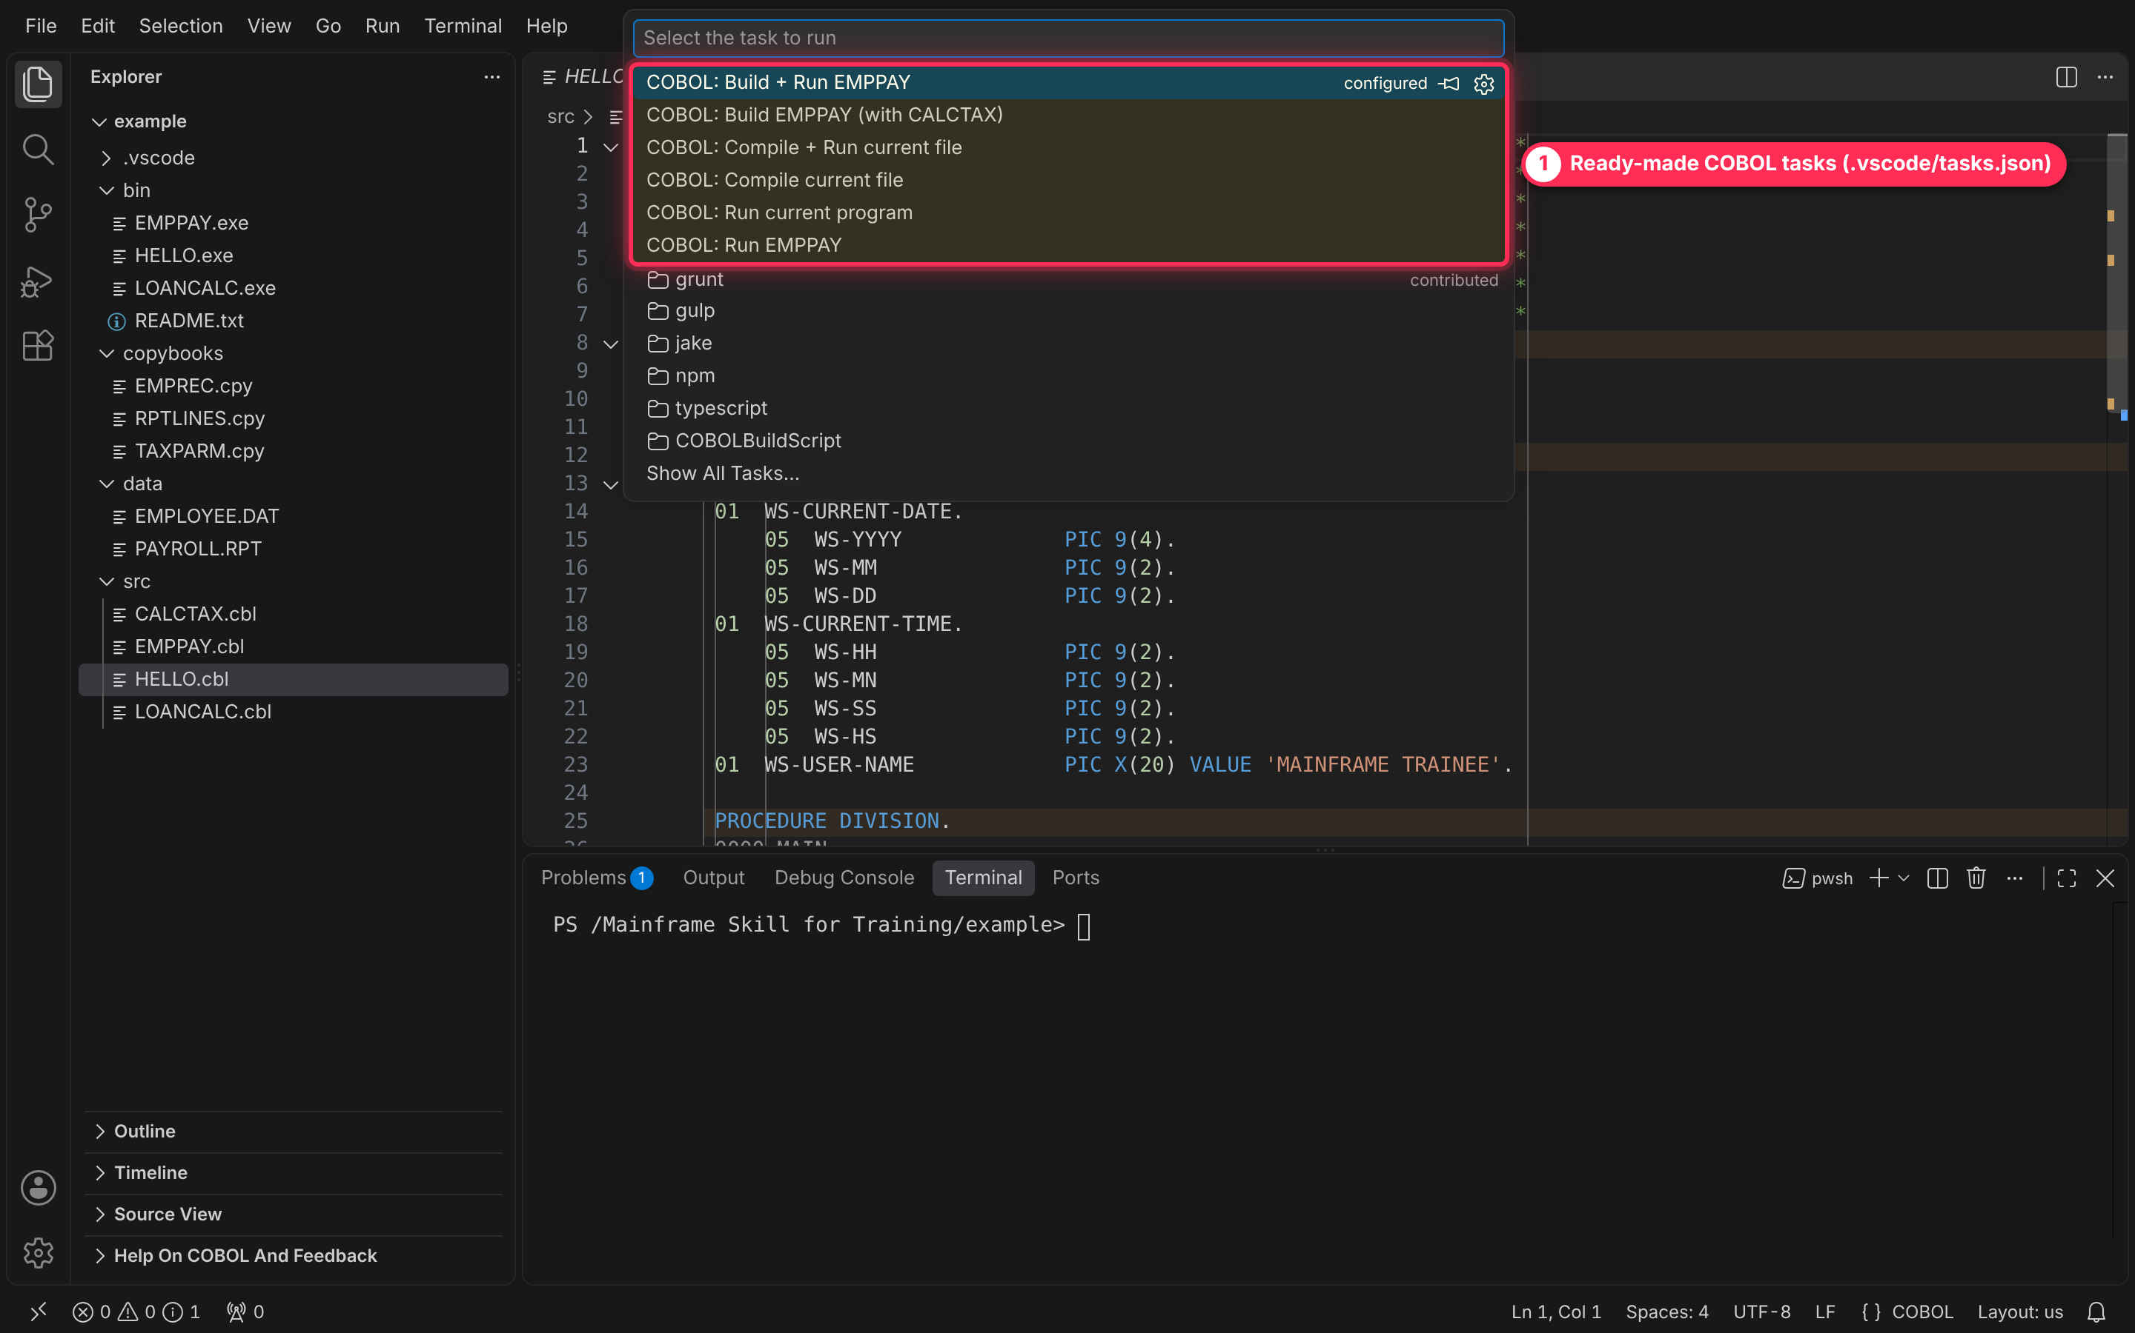
Figure 17 — The COBOL tasks in the task list.
One key: Ctrl+Shift+B
With HELLO.cbl or LOANCALC.cbl as the active tab, press Ctrl+Shift+B. The default build task compiles and runs that file; output appears in a task terminal. Press any key in the terminal to close it. Use Build + Run EMPPAY for Lab 3, because EMPPAY also needs CALCTAX.
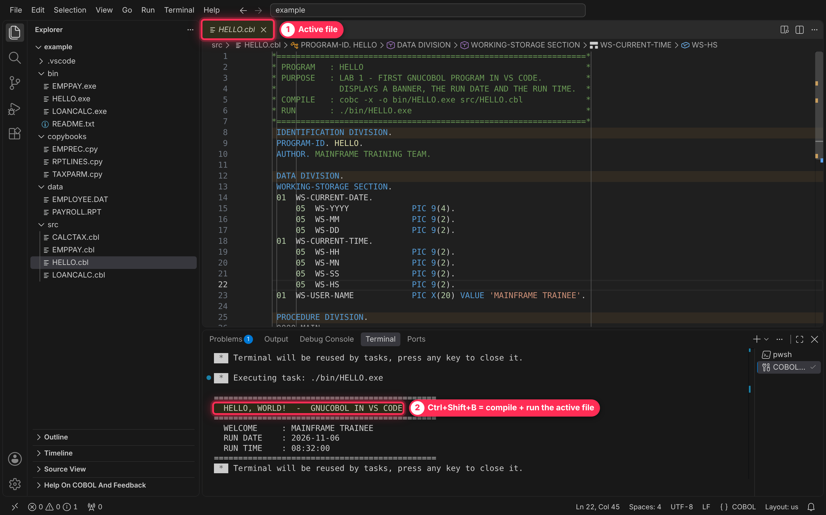
Figure 18 — Ctrl+Shift+B compiles and runs the active file.

Cheat sheet
On the mainframe | In VS Code with GnuCOBOL
Compile + link a main program | cobc -x -o bin/PGM.exe src/PGM.cbl
//SYSLIB DD for copybooks | -I copybooks
NODYNAM static CALL | -fstatic-call, with caller and subprogram on one cobc line
EXEC PGM=PGM | ./bin/PGM.exe
SYSOUT | The terminal panel
COND CODE | $LASTEXITCODE (PowerShell) or echo %ERRORLEVEL% (Command Prompt)
ASSIGN TO DDNAME + DD card | ASSIGN TO 'data/FILE.DAT' with ORGANIZATION LINE SEQUENTIAL
Browse a dataset | Click the file in the Explorer
Recall last command | Up arrow in the terminal
Save member | Ctrl+S
Clear the screen | cls

Troubleshooting
Symptom | Cause | Fix
cobc : The term 'cobc' is not recognized | GnuCOBOL's bin folder is not on PATH, or VS Code was open when PATH changed | Add it to PATH, close all VS Code windows, reopen, run cobc --version
EMPREC: No such file or directory plus many “not defined” errors | -I copybooks left off | Add -I copybooks; fix the first error, the rest follow
Compile fails saying gcc or the C compiler cannot be found | The GnuCOBOL install has no C compiler | Use a GnuCOBOL build that bundles one (MSYS2 or a full Windows bundle)
HELLO.exe is not recognized | PowerShell needs the path prefix | Type ./bin/HELLO.exe, not HELLO.exe
EMPPAY: OPEN FAILED ... FILE STATUS = 35 | Run from the wrong folder, so data/EMPLOYEE.DAT is not found | cd to the project folder (the prompt must end in \example>) and rerun
Columns 73+ silently ignored, odd syntax errors | Code past column 72 in fixed format | Keep code left of the last ruler line in the editor
No colouring, status bar says Plain Text | COBOL extension not installed | Install COBOL by Bitlang (Before you start, step 3)

